**1. Write a query for the HR department to produce the addresses of all the departments. Use**

**the LOCATIONS and COUNTRIES tables. Show the location ID, street address, city, state or province, and country in the output.**

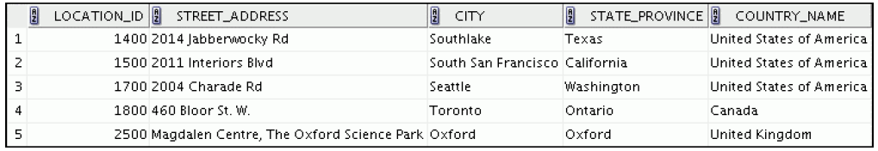

SELECT location_id, street_address, city, state_province, country_name

-> FROM locations

-> Natural JOIN countries;

**2. The HR department needs a report of all employees. Write a query to display the last name,**

**department number, and department name for all the employees.**

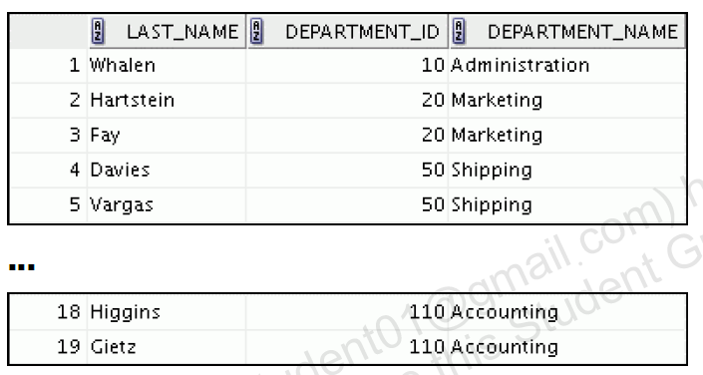

SELECT last_name, department_id, department_name

-> FROM employees

-> JOIN departments

-> USING (department_id);

**3. Create a report to display employees’ last names and employee number along with their**

**managers’ last names and manager number. Label the columns Employee, Emp#,**

**Manager, and Mgr#, respectively. Save your SQL statement as lab_06_04.sql. Run**

**the query.**

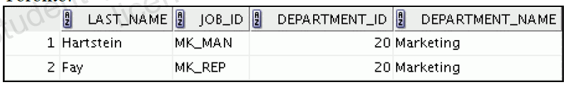

SELECT w.last_name "Employee", w.employee_id "EMP#",

-> m.last_name "Manager", m.employee_id "Mgr#"

-> FROM employees w join employees m

-> ON (w.manager_id = m.employee_id);

**4. Create a report for the HR department that displays employee last names, department**

**numbers, and all the employees who work in the same department as a given employee. Give**

**each column an appropriate label.**

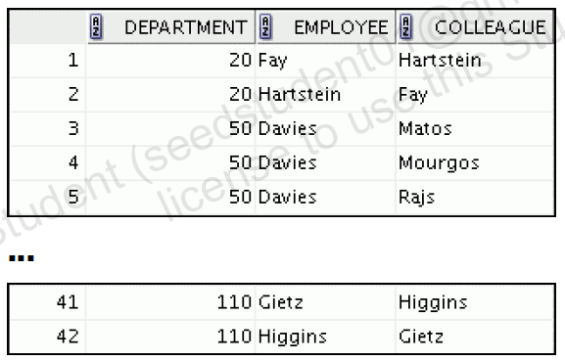

**5. The query should display the last name and hire date of any employee who work in the same**

**department in which Zlotkey (last name of an employee) work (excluding that employee).**

**6. Create a report that displays the employee number, last name, and salary of all employees**

**who earn more than the average salary. Sort the results in order of ascending salary.**

SELECT employee_id, last_name, salary

-> FROM employees

-> WHERE salary > (SELECT AVG(salary)

-> FROM employees)

-> ORDER BY salary;

**7. Write a query that displays the employee number and last name of all employees who work**

**in a department with any employee whose last name contains a “u.”**

SELECT employee_id, last_name

-> FROM employees

-> WHERE department_id IN (SELECT department_id

-> FROM employees

-> WHERE last_name like '%u%');

**8. The HR department needs a report that displays the last name, department number, and job ID**

**of all employees whose department location ID is 1700.**

SELECT last_name, department_id, job_id

-> FROM employees

-> WHERE department_id IN (SELECT department_id

-> FROM departments

-> WHERE location_id = 1700);

**9. Create a report for HR that displays the department number, last name, and job ID for every**

**employee in the Executive department.**

SELECT department_id, last_name, job_id

-> FROM employees

-> WHERE department_id IN (SELECT department_id

-> FROM departments

-> WHERE department_name = 'Executive');

**10. display the employee number, last name, and salary of all employees who earn more than the**

**average salary and who work in a department with any employee whose last name contains a**

**“u.”**

SELECT employee_id, last_name, salary

-> FROM employees

-> WHERE department_id IN (SELECT department_id

-> FROM employees

-> WHERE last_name like '%u%')

-> AND salary > (SELECT AVG(salary)

-> FROM employees);